Apostles Residents' Association Newsletter
November 2023
www.apostlesra.co.uk or follow us on X @apostlesSW20

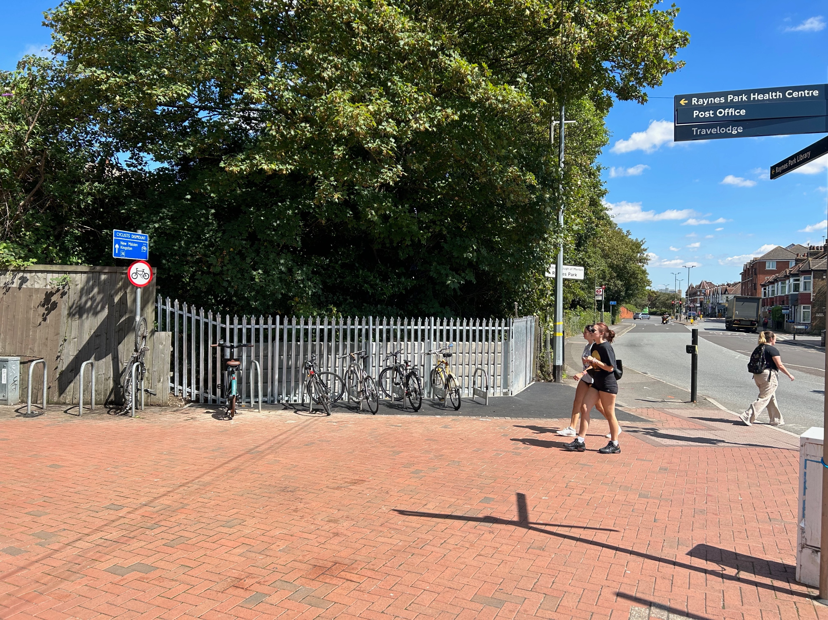
We’ve Now Got a Bit More Space!
For those of you new to The Apostles – welcome!

Chair’s Introduction
The front photo shows the widened pathway outside Raynes Park Station. It is perhaps just a small improvement, but I think you will agree it is a very welcome one. The previous narrow footpath at this point made it difficult for pedestrians – especially when a train arrived in the rush hour discharging many passengers! We have been campaigning for this project for over 10 years! We got there in the end!

You will no doubt have noticed activity on the railway embankment opposite Boots. Liz Lane and a number of volunteers have done a massive amount of work in clearing the embankment ready for planting. They have also done some difficult terracing work with planks of prepared wood. This project again took us over 10 years to set up thanks to the bureaucracy of Network Rail! However, we now have the key to the gate and permission to work on the embankment.

No newsletter would be complete without talking about car parking. Concern was expressed by Dundonald Church and by ourselves at the Council’s decision to ban parking entirely from the north side of Kingston Road adjacent to the church. This would have created difficulties for church members on Sundays and would cause an influx of parking in our streets. Whilst opinions are divided on this matter (as indeed they are on most parking issues) our own survey confirmed that a majority of people did not want such restrictions. We are pleased that Merton Council are going to re-consult.

We have given updates of local planning applications in this newsletter. I am grateful to Howard Scott for compiling these for us.

Finally, I want to thank our dedicated road reps who keep an eye on what’s happening in their street, and also to other committee members who help to keep our association running smoothly. All roads now have a rep – Henry has taken over as road rep in Dupont Road. Thanks to Tanya who has covered this task for many years!

Chris Larkman, Chair, Apostles Residents Association

chrislarkman@gmail.com
Are You on Our Email List?
We no longer have any effective local press, providing us with local information. We aim to fill that gap by keeping you updated with what is happening in the Apostle roads and in the surrounding area particularly Raynes Park. Are you on our list to receive mailings? If you are not, please email Chris Larkman chrislarkman@gmail.com giving your name, address and email address. We promise to bring you useful local information and not to inundate you with loads of unwanted emails! In particular, we use this mailing system to alert each other of any local crime. We act as a sort of Neighbourhood Watch Scheme, working closely with our local Raynes Park Safer Neighbourhood Team. Some road reps also send out notices to people in their individual street.
Street WhatsApp Groups
Some streets have their own WhatsApp group, which offers an additional means of communication. To join, contact the group organiser:
Gore Road: Will Reay - reayj2003@yahoo.co.uk
Clifton Park Avenue: Emma Cerpnjak 07835 470365
Prince George’s Avenue: Wayne Smart – text or contact him on waynesmartapostles@gmail.com
Carlton Park Avenue: Rebecca Reynolds - text or contact her on 07861 684341.
Edna Road: Caroline Smith – text or contact her on 07708 795065
Dorien Road: Martin Geoghegan - martinrpvale@gmail.com
Dupont Road: Tanya Withers - 07808 742083 tanya_withers@yahoo.com
Chestnut Road: Raluca Barret - ralucaxyz@icloud.com
Bronson Road: Brandon Wilkins – brandon.wilkins1@gmail.com 07470 048629

ARA Financial Statement
We currently have £3906 on our account. We spend the money on basic running costs, e.g. subscriptions for our website & MailChimp database, booking meeting rooms. We also use spare money to purchase additional trees to plant in our streets.
Time for Your Annual Subscriptions
If you haven’t already paid, please can you do so either by dropping it off at your road rep’s or online: Apostles Residents Association, account no 02383523, sort code 30-99-66 and put your name and address as the reference (e.g. Evans 3 Gore). (£4 per household and £2 for pensioners and unwaged.)
Apostles’ Family Community
Are you currently on maternity/paternity leave, shortly expecting a baby or have little ones at home? Rebecca from Carlton Park Avenue has set up an Apostles parent/carer and baby group. Please text her on 07861 684341 if you would like to be involved.
Parking in Kingston Road
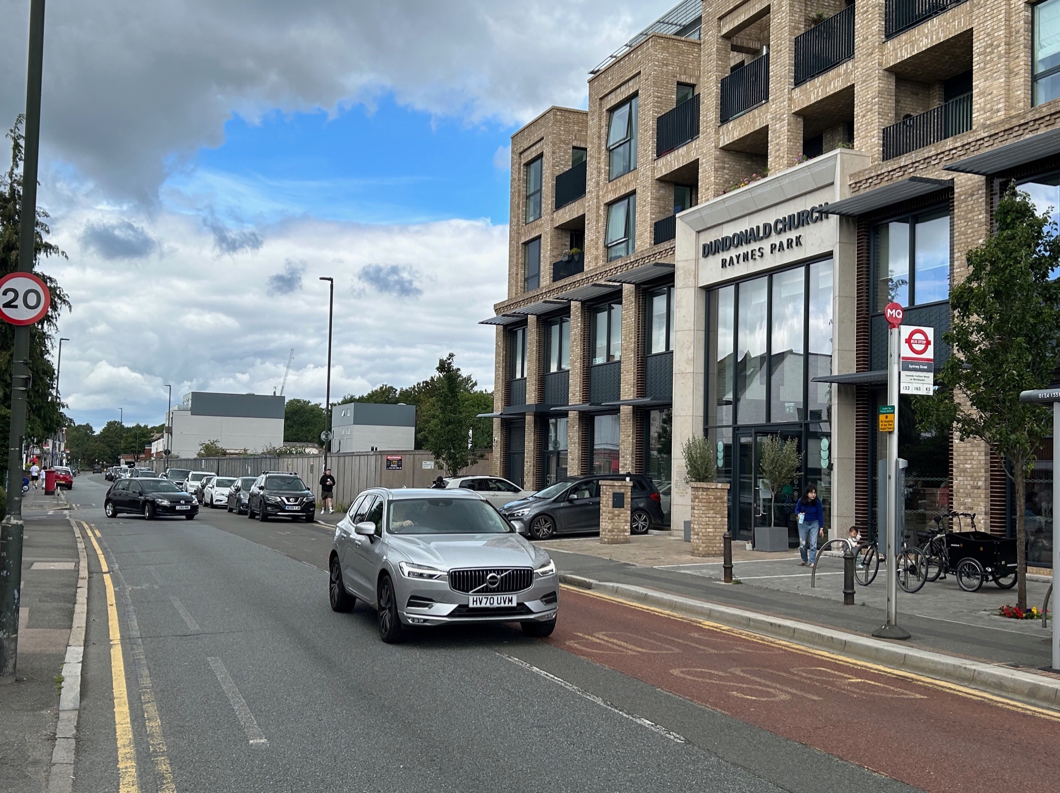
The ARA recently undertook a survey of residents using our MailChimp database. We hold email addresses for about half the residents of our streets and we had a 20% response rate. The result indicated that a majority of 82% of respondents were against any Sunday parking restrictions in Kingston Road, as opposed to 14% in favour and 4% with no preference. Edna Road and Dupont Road each recorded the highest number of YES votes: 6 votes in each of these roads. Nevertheless, in Edna Road only 32% were in favour as opposed to 68% against. Dupont had the closest result with 40% in favour, 47% against and 13% with no preference. Email Chris for a copy of the results road by road chrislarkman@gmail.com
Planning Applications
JUNCTION TAVERN, 641 KINGSTON ROAD – REFERENCE 19/P2769
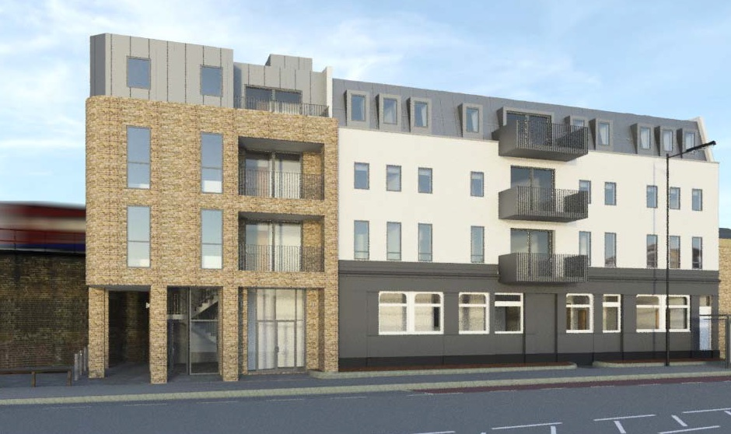
CHANGE OF USE FROM PUBLIC HOUSE TO GROUND FLOOR RETAIL (WITH 9 x FLATS ABOVE (COMPRISING 6 x 1 BED AND 3 x 2 BED FLATS) INCLUDING DEMOLITION OF EXISTING TAXI HIRE BUSINESS WITHIN CURTILAGE.
Planning permission granted in June 2019. The Developer is intending to progress with the scheme, for which consent was granted (as above), although there have been a number of structural design challenges to deal with, due to the proximity of the building to the railway embankment. A lot of works are being undertaken internally and they are hoping to soon be in a position to progress with the main build.

PAG SITE, 565 KINGSTON ROAD – REF: 23/P0455
DEMOLITION OF 3 SINGLE STOREY LIGHT INDUSTRIAL UNITS TO ENABLE REDEVELOPMENT TO PROVIDE 9 X RESIDENTIAL UNITS; SCHOOL (AGES 9- 13) WITH PUPIL CAPACITY OF 180; TEACHING COLLEGE; WORKSPACE; COMMUNITY CENTRE; AMENDED ACCESS; AND ASSOCIATED CAR PARKING.
Planning permission granted 24 August 2023. Demolition of the existing factory will take place imminently, but construction will not commence until a decision is made following the consultation on the possible (Church) car parking restrictions on Kingston Road. There are plans for a park and walk from Prince George’s playing fields (subject to agreement) to limit the number of drop offs directly to the school. The School has also agreed to fund a zebra crossing across Kingston Road near the junction with Sydney Road. The construction works are anticipated to take 35 months.
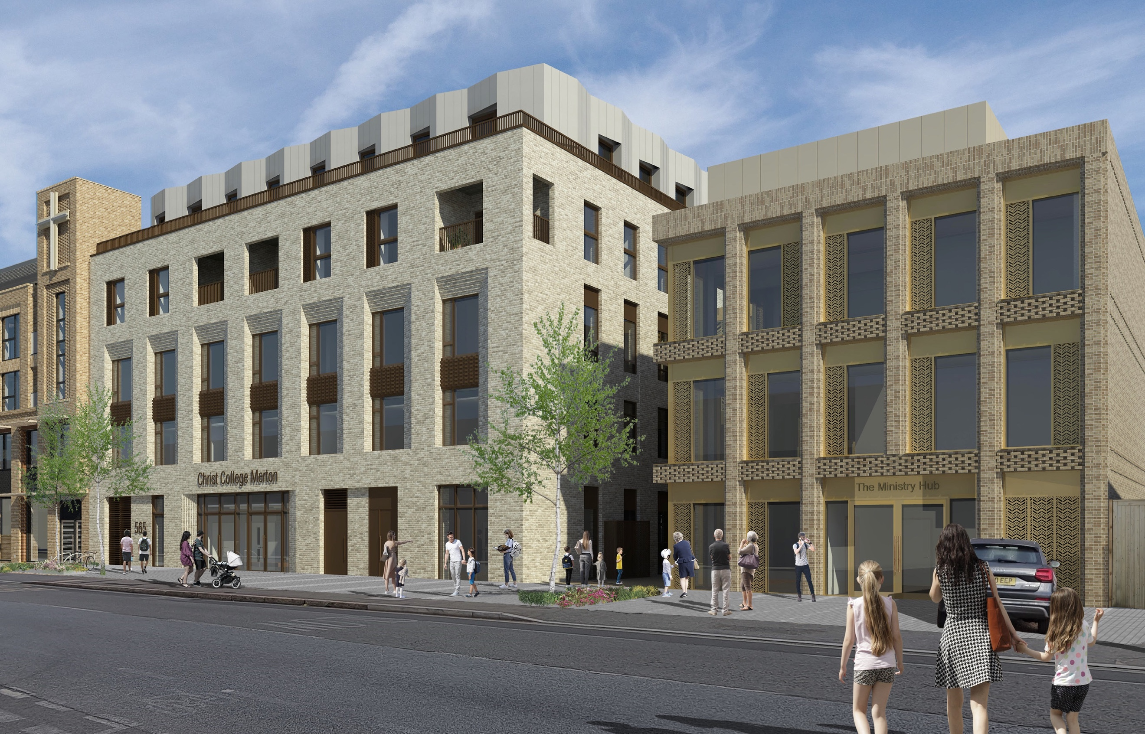

18 WHITFIELD COURT, 508 KINGSTON ROAD – REF: 22/P2120
This is the land between Sydney & Dupont roads where planning per-mission was granted in January 2023 for the erection of a 6th bungalow.
ERECTION OF A THREE-BEDROOM DETACHED BUNGALOW WITH A SUMMERHOUSE
A pre-requisite, before construction can commence, is submission of a Construction Logistics Plan and a Working Method Statement. These have not yet been posted on the LBM planning portal. Construction is anticipated to take four months. The land (with the benefit of planning permission) is believed to have been sold, but there is no indication as to when building works might start.
ACCESS SITE, 579-589 KINGSTON ROAD – REF: 23/P0869
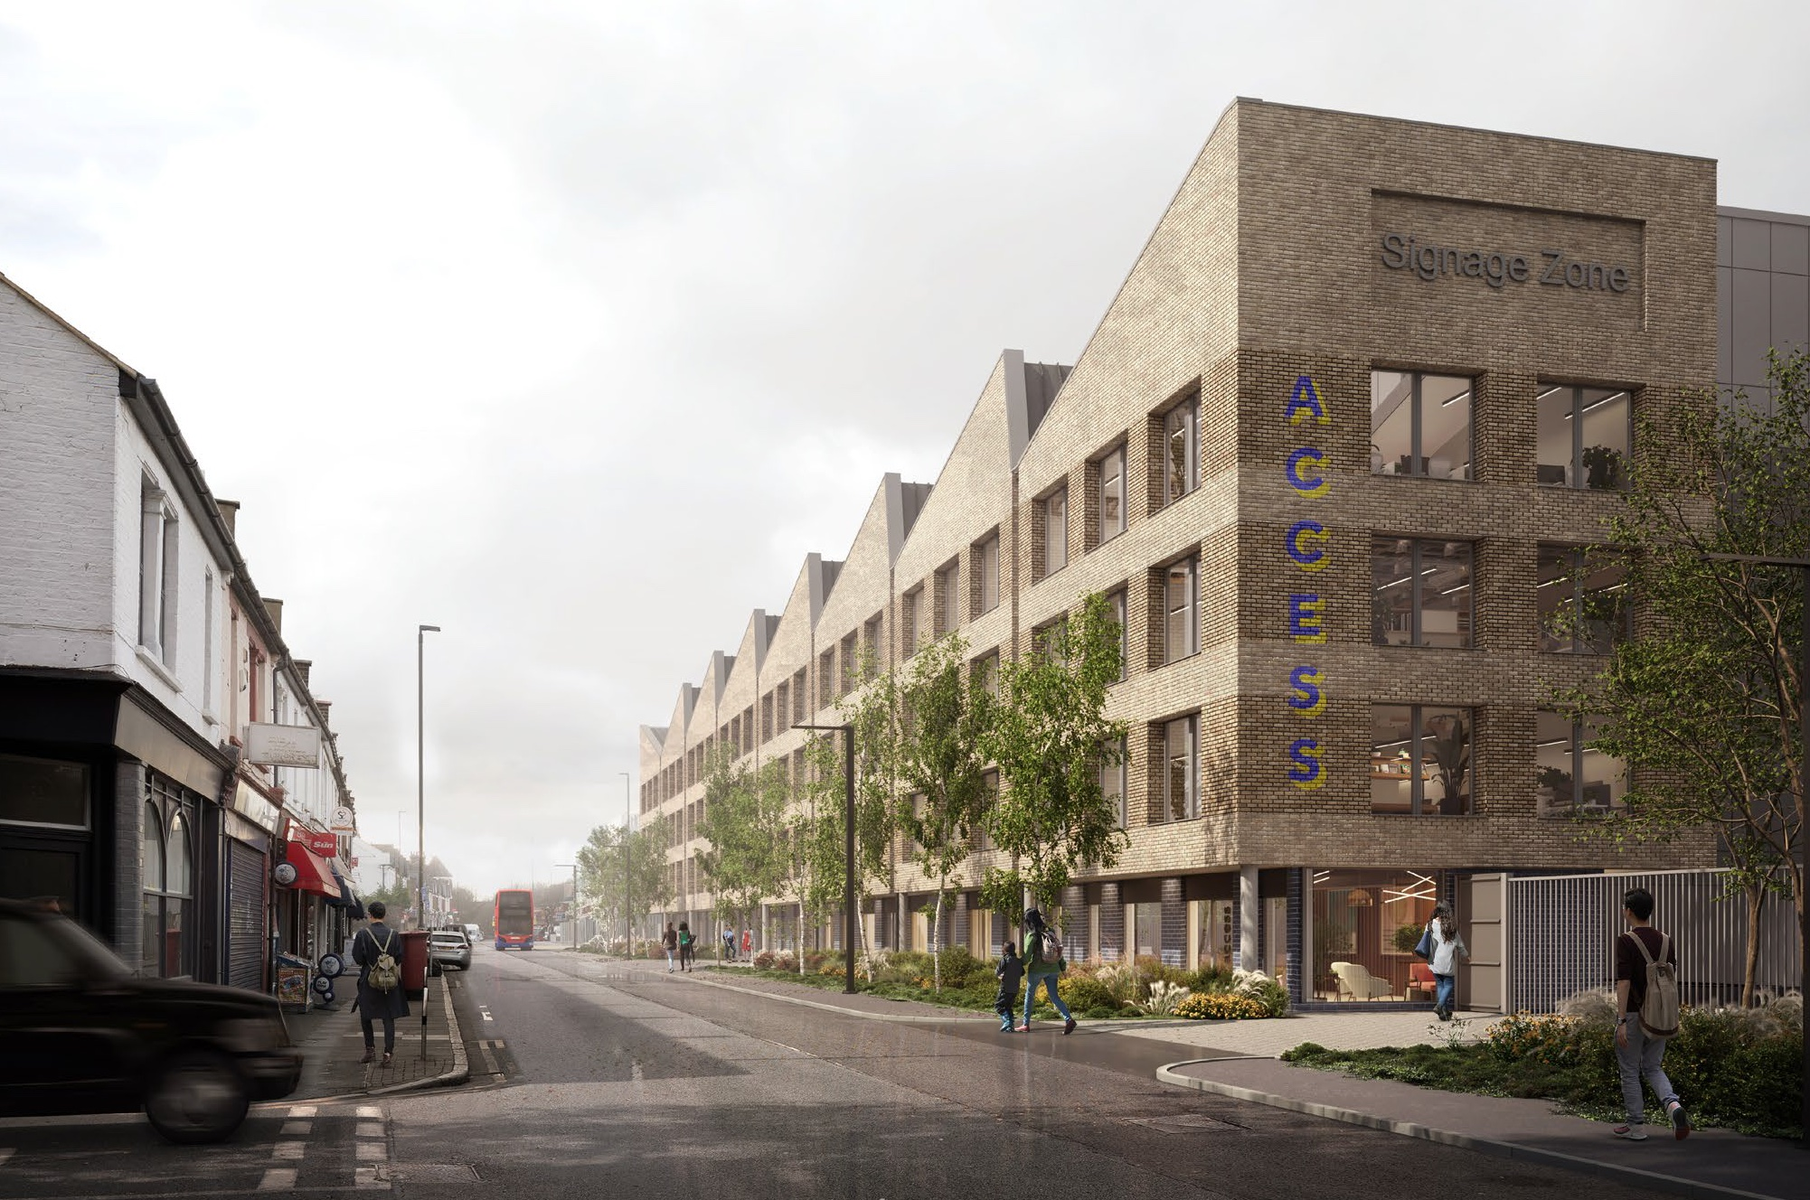
REDEVELOPMENT OF SITE TO PROVIDE LIGHT INDUSTRIAL AND SELF-STORAGE USES, INCLUDING USE OF PART FIRST FLOOR FOR (OFFICE) AND/OR SELF-STORAGE IN A BUILDING OF UP TO SIX FLOORS, PROVISION OF CAR AND CYCLE PARKING, VEHICLE ACCESS, LANDSCAPING, PLANT AND ASSOCIATED WORKS.
Planning Application submitted 24 April 2023. Not scheduled for Committee as of yet. If permission is granted the construction works are anticipated to take 18 months in total.
Traffic Speeding in Bushey Road
A group of volunteers work with the police to check traffic speeds on certain roads. Volunteers from the Apostle roads have been keeping a check on speeds in Bushey Road. In a period of one hour, they recorded 41 vehicles going over 34mph – the speed limit is 30. The highest speed was 53, then 49, 48, 44, 42 and 40. 5 at 39, 2 at 38, 9 at 37 and the rest 25 & 36. (This is just a data collecting event, so no fines will be imposed.)
Our Trees
Many residents have complained at the lack of management of our trees by Merton Council, and in particular the cycle of pollarding. The Council has a timetable for proposed tree work, though nothing has so far materialised. A survey of dead trees was made with the intention of grinding them to ground level, covering the plot with soft tarmac, to satisfy Highways, until the trees are replaced. One of 4 dead trees in Sydney has been ground down - no tarmac so far. To see Merton’s tree strategy go to the Merton Council website.

The Embankment
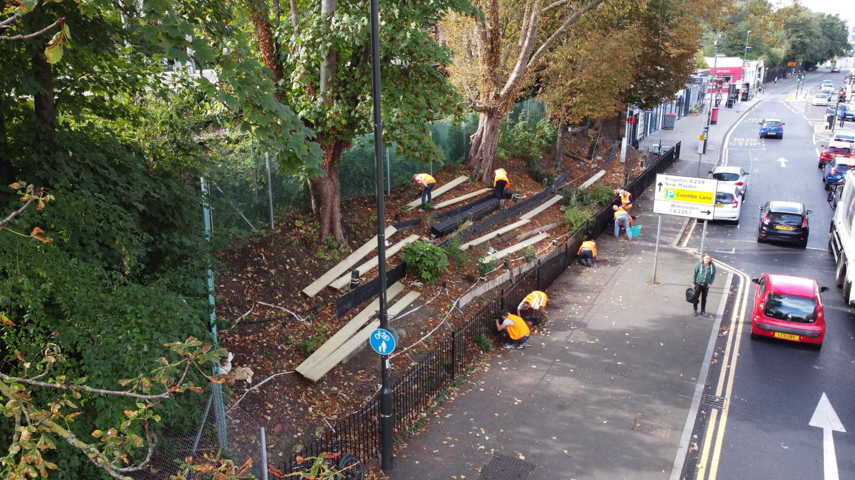
Volunteers Working to Create the Embankment Garden

Our Local Police
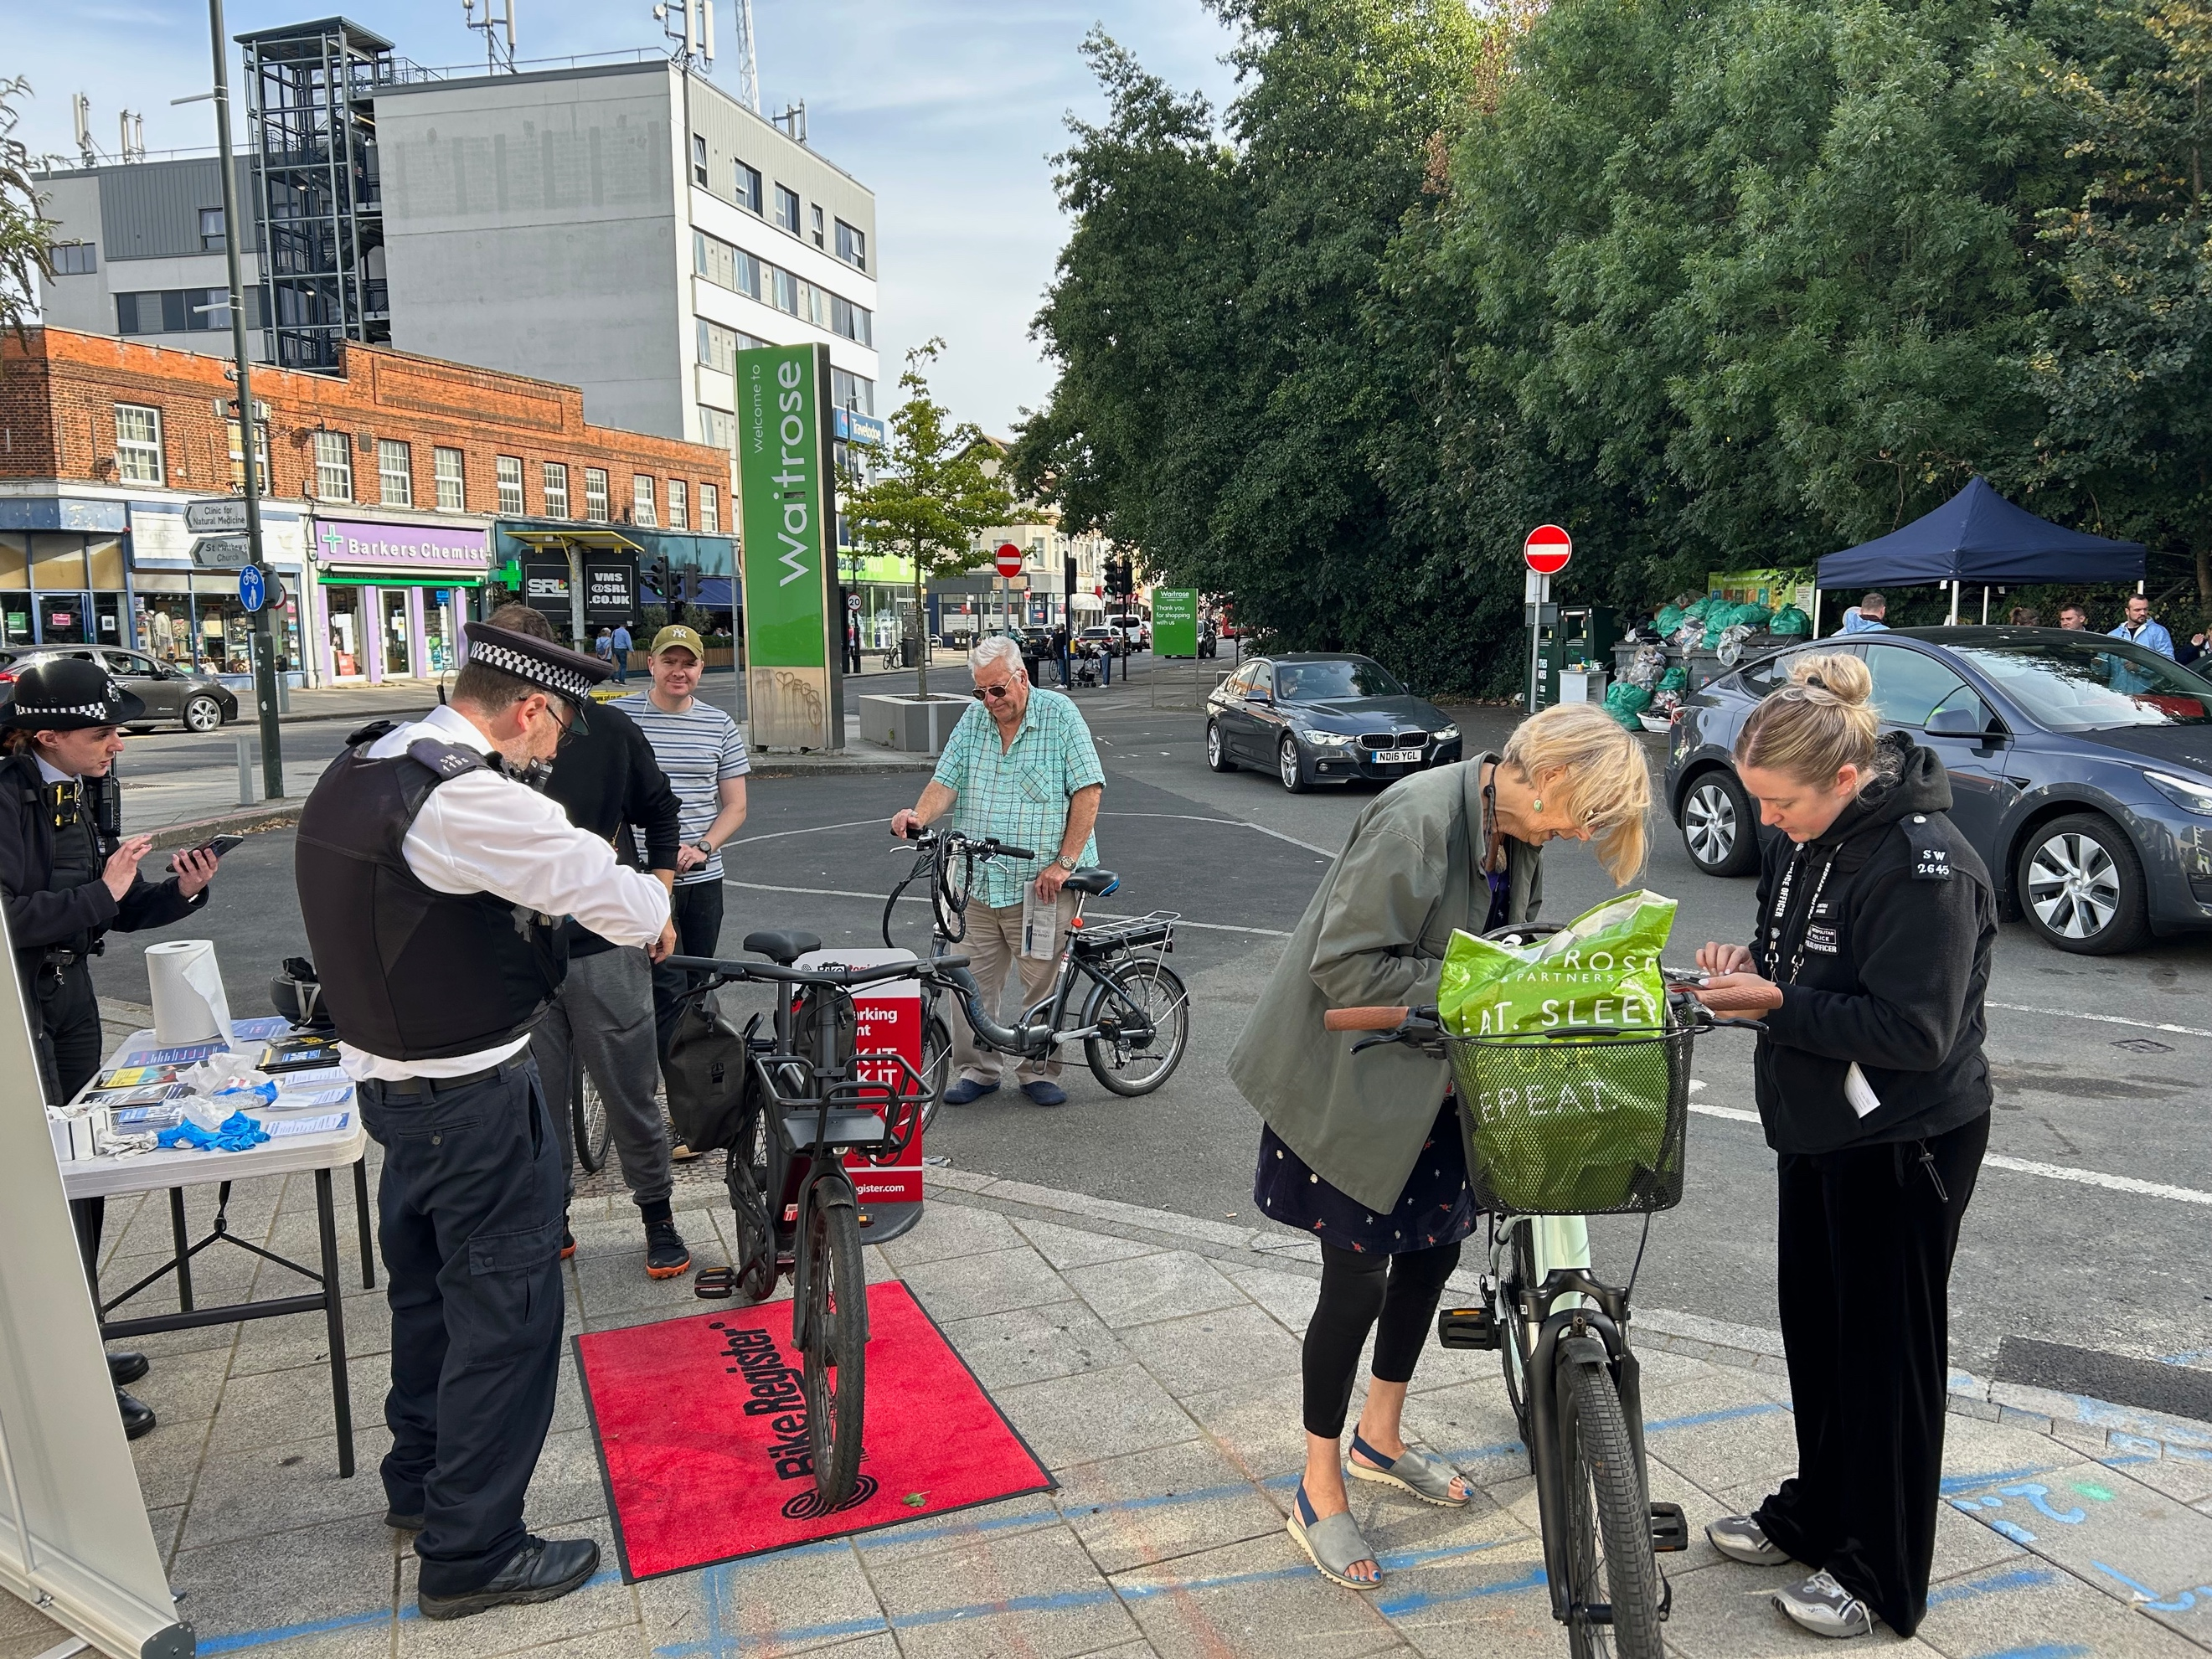
Members of our Local Police Safer Neighbourhood Team in Action
Our police team regularly arrange security marking sessions both for bicycles and catalytic converters. They have been very active recently in addressing burglaries from front gardens and parked cars. There has also been a lot of theft from our local shops and supermarkets and they are targeting the young people responsible. Make sure you report any crime or attempted crime to the police – the more information they have the better the chance of an arrest. In an emergency (e.g. the suspect is possibly still at large) call 999. The police non-emergency number is 101. To contact our local Raynes Park Safer Neighbourhood Team call 020 8721 2459 or email them: raynespark@met.police.uk - but don't expect a swift reply!
Local Book Club

A local book club which meets approx every 6 weeks, usually at Mora, would welcome new members, contact Jane: jane.sin@hotmail.co.uk
Raynes Park Station Drop-Off Area
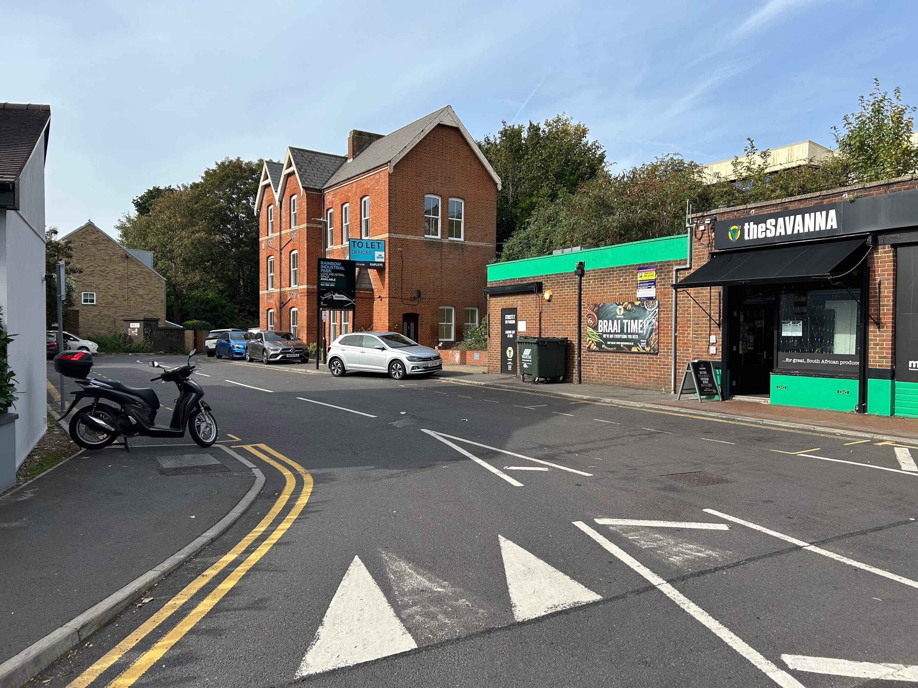
We’ve been running a campaign with the owners of this bit of land – Workspace – to get them to enforce the 20 minute parking restrictions on the 6 bays marked for people to drop off and collect people from the station, and also to pop into the odd shop. Finally we have succeeded. Workspace erected additional signage – though one was soon knocked down – and a traffic warden. However, drivers have cottoned on to the fact that the warden has currently no authority for ticketing anyone parked on the yellow lines or pavements – what a daft situation!
Coronation Street Party – Bronson Road
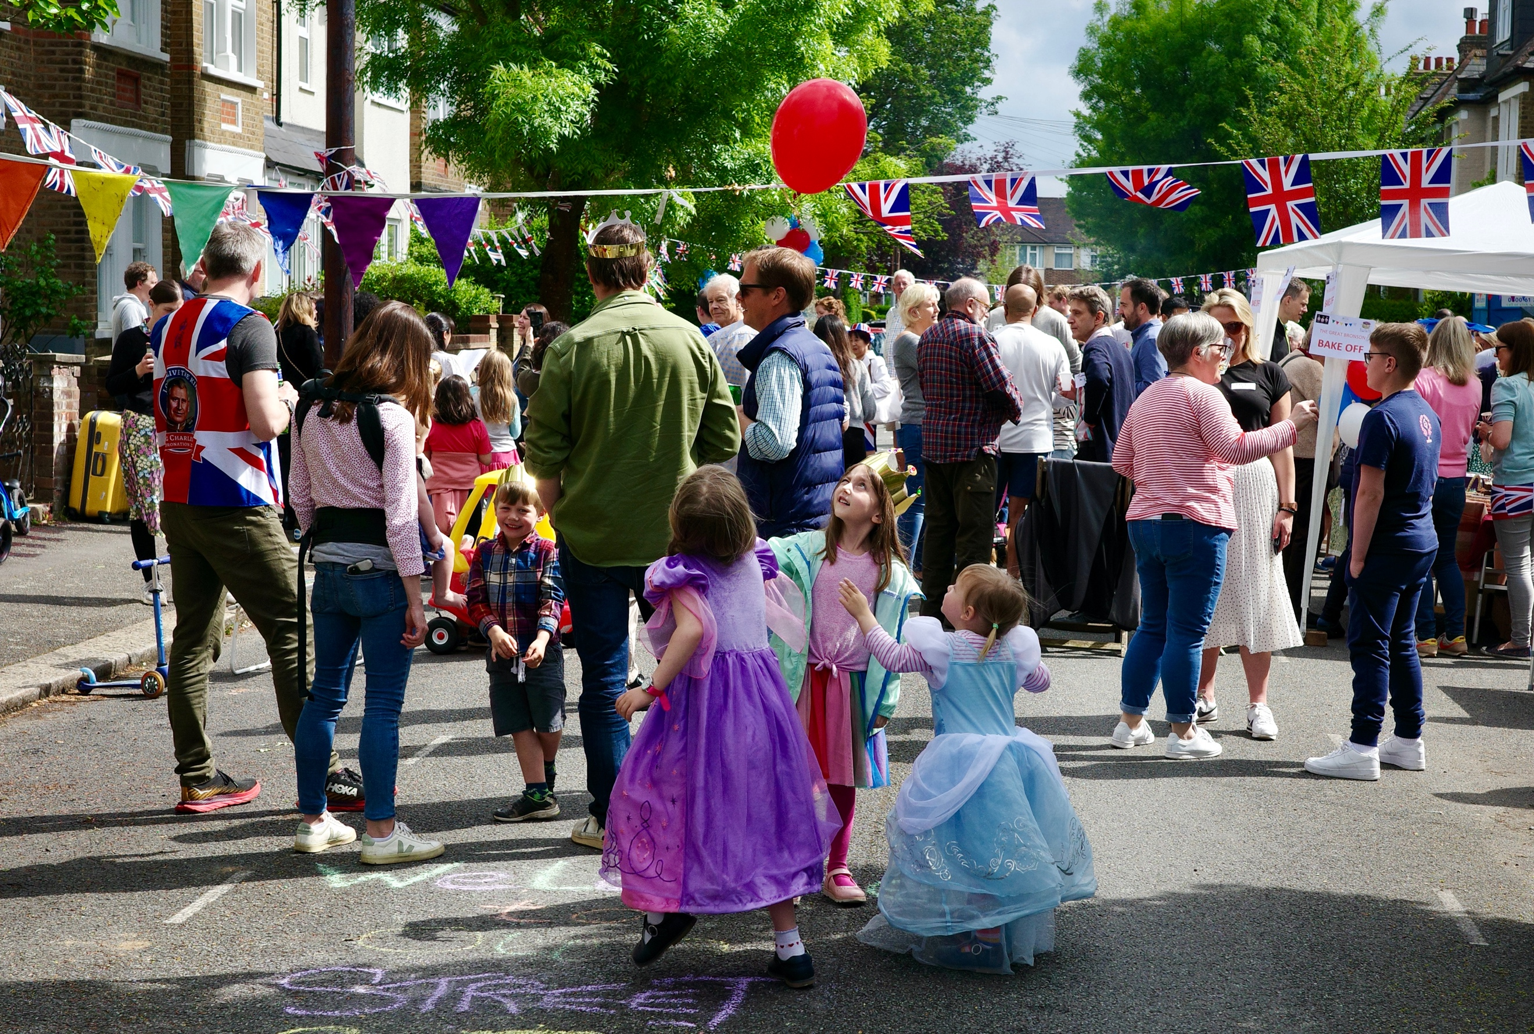

ARA Committee Members Officers
Chair – Chris Larkman 25 Bronson Road - chrislarkman@gmail.com 07950 642550
Treasurer – Simon – apostlestreasurer@gmail.com
Membership Secretary – Jenny Gregory
86 Vernon Avenue - jennyangreg@aol.com 020 8540 2627
Gore Road – Will Reay (31) – reayj2003@yahoo.co.uk
Clifton Park Avenue - Jenny Irvine (26) – 07968 173808 jirvine26@gmail.com
Aston Road – Stephanie Golden (34) – astonroad@talktalk.net
Prince George’s Avenue – Wayne Smart (34) – 07866 388443 waynesmartapostles@gmail.com
Carlton Park Avenue – Kate de Vere (53) – 07889 235840 katedevere55@gmail.com
Vernon Avenue – Edward Clark (51) - 07831 361992 ainola@blueyonder.co.uk
Edna Road – Brad Taljard (3) – 07906 179808 btaljard@yahoo.co.uk
Dorien Road – Martin Geoghegan – martinrpvale@gmail.com
Dupont Road – Henry Tayler – 07792 514411 henrytayler@gmail.com
Sydney Road – Howard Scott (31) – 07920 726571 scotthoward747@gmail.com
Chestnut Road – Raluca Barret – ralucaxyz@icloud.com
Bronson Road – Rae Davies (83) - 020 8540 2516 raedavies@hotmail.co.uk
Kingston Road – Marcin Kaczor 07742 935656 marcin.kaczor@hotmail.co.uk
Sponsored by

